Book of Revelation

CHAPTERS 11-12

OUTLINE

Revelation – First Half or Second Half of the Tribulation

Chapter 11

Measuring the Temple
The Times of the Gentiles
The Two Witnesses

Chapter 12

The Woman Clothed with the Sun
The Dragon – 7 heads, 10 horns
Persecution of the Woman, Her Flight, Satan’s Defeat
Persecution of Her People

Book of Revelation

CHAPTERS 11-12

Which Three and One-Half Years?

Many treatments of Revelation place all or most of the events in the latter half of the seven year period of the tribulation. This is based on two conclusions. The second half is often referred to as the Great Tribulation, and if so, having so many truly horrifying events in the first half would seem to lessen or steal the title away from the second half.

Secondly, Jesus gives us an order of events in the Olivet Discourse that would seem to make it ironclad that the events of Revelation must come after the Abomination of Desolation – which is in the second half.

Taking events away from the second half doesn’t serve to lessen its designation as the Great Tribulation simply because that period has added to it the evil persecution of antichrist, which is more in keeping with the idea of tribulation in the Bible as a whole. Tribulation is more often connected with persecution for the faith, whereas the judgments of the first chapters in Revelation are not due to people’s stand for Christ.

Closer examination of the passage in Matthew 24 regarding the placement of events actually creates more difficulties than the simple solution of where events might go. Notice the words of 24:29, “Immediately after the tribulation of those days . . the sun will be darkened, and the moon will not give its light, and the stars will fall from heaven,”

So the words that would link us to chapters 6 and 8 in Revelation regarding the effects on the sun, moon and stars, don’t just come after the Abomination of Desolation, they come after the entire tribulation, according to Matthew 24:29.
A of D


Taking this in the context we hope to use, this would mean they would appear at the Second Coming or thereafter. This is not in keeping with what we do see in the Revelation, where they appear quite clearly during the tribulation events and well before the Second Coming.

So we are forced to search for some other meaning for the tribulation Jesus is referring to.

If we notice that Jesus begins answering the disciples’ questions by listing the signs before His coming again. These signs are meant to intensify in the period before His coming.

He includes in those birth pangs that they will be delivered to tribulation. If there will be tribulation just before the commencement of the Seventieth Week of Daniel, this may be the tribulation meant by Jesus in His words, “after the tribulation of those days, . .”, meaning after wars and rumors of wars, after you must give testimony before kings, etc., then we might align the events that follow (the sun, moon and stars) with those seen in chapters 6 and 8 of Revelation.

This doesn’t settle the question of where in the seven years these events will occur, but it removes the supposed proof text that they must occur after the Abomination of Desolation.

Another interpretation that keeps the Revelation events in the second half would be to understand Jesus’ words about the tribulation of those days to mean the tribulation immediately following the Abomination of Desolation.

Problems with All Revelation Events in the Second-Half Period

The primary concern for placing all these events in the second half, is the sheer number of things that have to take place and the number of things which will then overlap which do not seem to reference each other.

The events of chapters 6-12 do not mention antichrist in his persecutorial role while the earth is being simultaneously judged by God from Heaven. Likewise, when antichrist as the beast steps on the scene, there is no mention of the overlapping judgments from chapters 6 – 10. Even if one proposes that they would be occurring early in the second half, not entirely through it, antichrist would be present throughout, and the details of his career are focused on many other details than what would be obvious, coming from the skies and the heavens.

This also sets up a sort of jockeying back and forth from the middle to the beginning of this second half to start different narratives from their beginning points. So we start with chapters 6-10, but then must start back at the beginning of the second half with the appearance of antichrist as the beast.

While cataclysms are happening on the earth, there appears to be time to set up worship of the beast by the false prophet, set up of commerce on the basis of the mark, etc. Babylon as a great city is allowed to flourish, supposedly amid such devastation happening at the same time.

The other difficulty is that the ministry of the two witnesses and the Gentiles being given the outer courts of the temple cannot apply to the second half, but must occur in the first half (as we shall see later in this lesson).

This creates the effect of having chapters 6-10 occurring in the second half - then we are moved backward to the first half for the two witnesses and the measuring of the temple and the Gentiles - then back to the second half for the appearance of the two beasts. Not a smooth, straightforward flow of events across an unfolding scene.

While nothing is ironclad as to where events must occur, it seems too forced to place everything seen in the Revelation in just the latter half. But understand, this is a supposition and a point of analysis, not an infallible observation. And interpretations of Jesus’ words in Matthew 24 may be decisive for some.
CHAPTER 11 – The Measuring of the Temple

Chapter 11 is dominated primarily with the account of the Two Witnesses, their death and resurrection. But there is a scene that precedes this, that continues John’s participation in the interlude begun at the end of chapter 10.

The interlude in chapter 10 showed us the image of the strong angel with the little book, and the seven thunders which John hears but must not write down.

Chapter 11 keeps John in this same vision but turns his attention to something new.
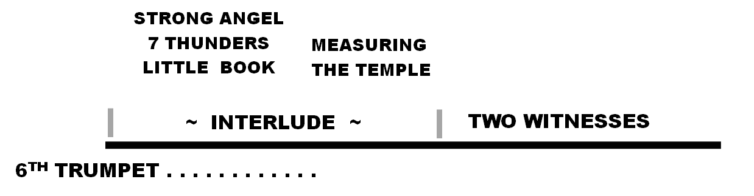

John is made to see the Temple of God and is given a rod and the command to measure. This picture is similar to what Ezekiel was made to see in his prophecy – a man measuring the temple. This is not a case of John doing what Ezekiel saw, because the temple of Ezekiel is enormous and anticipated as the perfection of final things, whereas the temple John measures has limitations imposed upon it, such as would rule it out as Ezekiel’s building.

It is not the Herodian temple, since that was now destroyed when John was writing. And there is no indication that the Jews will rebuild what Herod built.

An important distinction is the warning to not include the outer courts which are given to the nations (the Gentiles), such that this temple can be viewed as something less than God’s desire.

The command to measure is to declare what is the Lord’s and what is given to the Gentiles. In Ezekiel, the whole of the Temple will belong to the Lord. In Revelation, only the inner court or temple proper belongs to Him.

The measuring here is to show the state of ownership and that it is mixed. This helps us to determine which probable side of the tribulation period is meant by the sharing with the Gentiles.

The statement reads: “is given to the nations, and they shall tread underfoot the city for forty-two months.” This designation tells us it certainly will be in one of the halves. Which one is just a process of elimination.

If in the second half, we have some difficulty immediately with the fact that the Abomination of Desolation has taken place midway, and this event has already made the Temple desolate. So it would be illogical for the Lord to be measuring the Temple to show what is His and what is the Gentiles’ when He has fully abandoned the Temple altogether.

This leaves the first half as the period for the forty-two months.
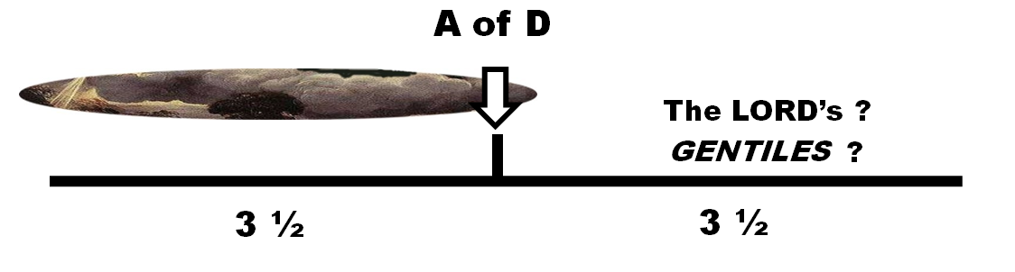

What we also learn however, is that the temple the Jews will rebuild will not be a singular victory over those who have controlled the area for so long. Even this new temple will be shared with the Gentiles and will not be exclusive. Which opens the question of whether the Dome of the Rock must be destroyed to make way for the smaller court of this new temple proper or will it be forced to share space side by side?

The Two Witnesses – Real or Symbolic

Many approach this account as widely symbolic with many interpretations offered, contrary to taking it as normal language of plain sense understanding. The primary reason is the almost immediate statement, “these are the two olive trees and the two lampstands before the Lord.”

Not only is it hard to relate persons with olive trees, but in the same sentence they are also described as lampstands.

But from a practical and logical standpoint, olive trees and lampstands:
- don’t speak and prophesy
- don’t perform miracles
- don’t die in bodies that can be seen as fitted for tombs
- don’t respond to “Come up here.”
- aren’t resurrected as people will be.

So it is clear that the imagery in heaven is how the Lord sees their meaning in His eyes, rather than who they are in reality.

In Zechariah 4, the prophet is given a similar vision related to the ordaining of Zerubbabel in rebuilding the temple. The explanation given to Zechariah is that the work will not be by might, nor by power, but by His Spirit. Zerubbabel’s work is empowered by the Spirit above everything else.

What does this have to do with our two witnesses? They too are on a mission which tests whether they will do it in their own might and power, or by the Spirit of God. God is showing John that their ministry is to be fed by the Spirit.
Why the olive trees and lampstands? The lampstands are the things operating, that which is performing the Lord’s will. The olive trees are giving the lamps a constant source of their pure, unspoiled oil, so there is no doubt that they get their source of light and energy from the oil – which is a figure of the Spirit.

The Two Witnesses – Their Ministry

They minister strictly in the city of Jerusalem – despite the mystical names of Sodom and Egypt – which are immediately clarified as the city where Christ died.

Despite being protected during their ministry from those who would try to kill them, they are overcome by the beast who comes from the abyss. So far we have not been introduced to this figure. He first appears in chapter 13 and is also explained more in chapter 17.

Strangely, in chapter 13 he is identified as coming from the sea, not the abyss. But by chapter 17, this same beast reappears in the narrative and is clearly a beast from the abyss.

Also, we have no reasons for inferring that there are instead many beasts: one from the abyss for the two witnesses (ch 11), another from the sea as the beast with the false prophet (ch 13), and yet another again from the abyss who carries the harlot (ch 17). They are all one and the same. John is using terms interchangeably for reasons that are not completely understood.

What is interesting, is that the beast from the abyss cannot be killing the witnesses at the end of the second half of the tribulation, because he will be on the verge of destruction himself at the appearance of Christ (2 Thess 2:8)

He is however very available to be revealed in the first half of the period as having changed character to the new persecutor of God’s people after the witnesses 1260-day ministry – right at the midpoint when such a change is expected.

The Two Witnesses – Identifications

As to who these witness might be, the most popular identifications are Moses and Elijah and Elijah and Enoch.

Moses and Elijah are readily seen because of the miracles – each performed one of those mentioned: turning water to blood, shutting up the rain. They also appeared at the Transfiguration, which might be seen as an indication of whom God plans to use in post-life appearances.

Elijah is a good candidate also because he did not die but was translated, and many like to cite the verse “it is appointed for a man once to die. .” Heb 9:27.

But Moses would be ruled out, even if we don’t appeal to Hebrews 9:27 because he would be made to die twice.

Enoch is another good candidate in that he did not die, being also translated instead. But he did not perform in life any of the miracles cited, nor was he at the Transfiguration.

All of which is to say that we may be straining too hard to consider the historic miracles and how they are tied to the witnesses – which once alleviated would allow Elijah and Enoch to appear. They would not be dying twice.

But also, we are free to consider that God may use completely different persons whom He has prepared for end times, and who will repeat the miracles mentioned, which is not impossible at all.

Note: What’s Left For the Second Half?

It might be argued that with so much crammed into the first half of the tribulation period, there is now just the opposite effect – not much to occur in the second half.

But plenty is still quite available to fill its time period:

- The arrival of the Beast in his role as the antichrist
- The appearance of the False Prophet
- The set up of worship and commerce related to the Beast
- The rise of commercial Babylon and its fall
- The great bowl judgments
- The battle of Armageddon

The Seventh Trumpet

With the end of the Two Witnesses, the Second Woe is past. The seventh angel begins to sound.
And again, another interlude that takes John back into the heavenly scene of the Throne of God.

Here he hears voices saying: “the kingdom of this world is become the kingdom of our Lord and of His Christ.” (Handel will be disappointed to see they are not singing it.)

This is followed by John seeing again the Twenty-four Elders in worship before the throne, followed by a vision of the Ark of the God revealed in the Temple in Heaven.

As to this being the actual physical article trekked around by the Israelites and later lost, no one can truly say. There may be perhaps a divine model of the true Ark that has always been in Heaven since the command to Moses to build one, and this is what John sees.

Since there is no known history of what did happen to the Ark after the Philistines (plenty of speculation), nothing prevents the explanation that it was taken into Heaven by God, preserved for just such a moment as this.

The main point is that God is here declaring that the Law and the covenant He established with Moses is not forgotten, and will serve as the basis of judgment for all men who refuse to accept the grace that is in Christ.

CHAPTER 12
The Seventh Trumpet (continued) - The Woman Clothed with the Sun

With chapter 12, John continues the heavenly interlude which is now used as a historical vignette to tell the story between the woman, her child and a new character - the dragon.

This vignette will take John back into the past and well away from the events he is seeing on earth and in Heaven. But it is necessary that John and the Church come to understand the long-standing relationship of the one whom the dragon personifies and the plan of God in salvation and in his people Israel.

The woman is described as clothed with the sun, having the moon at her feet and crowned with twelve stars. Those unfamiliar with the Bible find this imagery perplexing and mind-boggling.

Yet God is actually using imagery that has already appeared in the Bible. So those with a reasonably good memory, or the tools to search, will find that such images are not new nor deliberately perplexing, but intentionally thematic.
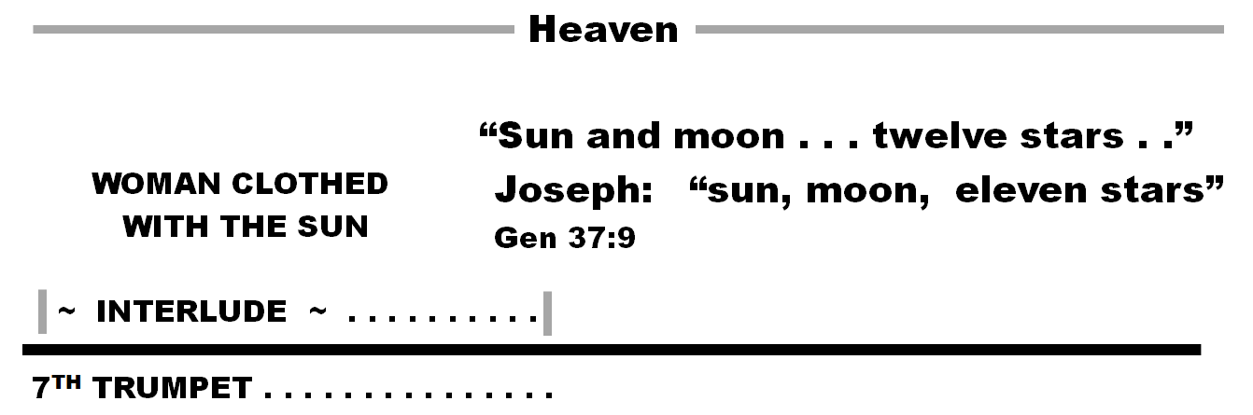

The sun, moon and stars were used with Joseph in his dream (Gen 37:9) of what his parents and brothers would do when he became a ruler in Egypt. The picture is what is important – that Jacob, Rachel, and the eleven brothers - as Israel - were pictured as the sun moon and eleven stars.

Whatever the meaning in God eyes, it is being repeated here in John’s vision. So the woman is Israel. And we see that she is about to give birth. The only birth that can be of significance is that of Jesus. And we see also a dragon who is ready to devour the child when born. Such symbolism is too similar to the historic circumstances of Christ’s birth to be avoided.

But here we are introduced to both new and familiar symbolism in this dragon which needs explanation because it is almost identical with that seen later in chapter 13 with the coming of the beast from the sea.

The dragon has seven heads and ten horns. We haven’t seen any imagery for seven heads anywhere in the Bible up to this point, including the one place it might have been seen – Daniel. This is entirely new. But we will set it aside for the moment and concentrate on the ten horns.
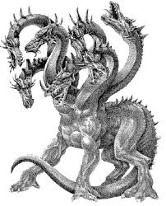

We certainly have seen the ten horns before – in chapter seven of Daniel – associated there with ten kings that will come out of the fourth kingdom – Rome. When in Daniel, we concluded that these kings did not appear in historic Rome, and are reserved for an appearance in end times to be associated with the coming prince who is the antichrist.

So our first conclusion – aside from understanding the meaning of the heads – is that this is that coming prince – the antichrist, who would certainly be against Christ, and be pictured in this way.



But historically, antichrist was not on the scene at the birth of Christ, unless one wants to talk about the spirit of antichrist being always in the world. But we are stopped from that conclusion anyway, because at v.9 we are told in clear terms who the dragon is.

9 And the great dragon was thrown down, the serpent of old who is called the devil and Satan, who deceives the whole world” But then why the imagery we will associate very soon with the beast who is the antichrist (chapter 13)?

If Satan is the empowering force of the beast, then giving him the same imagery makes sense since the beast is his star child on the earth. It is to identify both with the same imagery since they have the same mind and purpose and share the same heritage of evil.

As for the seven heads, they are explained directly in Revelation itself (chapter 17), so we will wait for that chapter to study them.

It is unclear however if the beast has the imagery because Satan has it first or if Satan has taken on the imagery because his Man carries it?

The Child Caught Up to Heaven , The Woman Flees

We next see that the child having been born is caught up to heaven and to his throne. No doubts that the child is Jesus. But Jesus was not caught up to His Throne immediately after His birth, nor would it have been done to avoid the devouring of Satan.

This has prompted some to offer that this pictures the flight into Egypt, since that is the only event which spares Jesus from Satan’s destructive act immediately after His birth. Our problem is that “catching up to heaven” and a throne don’t describe Jesus actions in the flight to Egypt.

Surprisingly there is similarity in what the woman is described as doing:

“Then the woman fled into the wilderness where she had a place prepared by God, so that there she would be nourished for one thousand two hundred and sixty days.” But here too, the family did not stay a neat duration of 1260 days in Egypt. And the 1260 days should ring a bell that this belongs in in the tribulation period rather than in history past.

So we are at a loss to see these descriptions pointing consistently to the events of the past. What helps is what follows next.

John is made to see another scene (vv. 7-17) that seems to go back further in time before the first scene but then overtakes the scene with the woman (vv.4-6). And in so doing this helps to explain when and how the child can be properly seen going to His throne at the Ascension and the woman might take refuge for 1260 days at the time of the tribulation.

The key is that the dragon is thrown down to the earth. The time is not made clear but when he is thrown down he persecutes the woman who gave birth. So in this expanded scene being shown she is persecuted – not hurried away to refuge. This persecution is therefore not the same as that from which she flees in the prior scene. Which means a different time and a different persecution period.
So Israel is not spared but persecuted – as Israel has been historically since the birth of Christ.

Such persecution can be seen as part of some kind of interval that must exist between the child being caught up to heaven and the woman fleeing with wings in the first scene above. But it is enough to separate the fleeing of the woman with her giving birth to her son.

True, there is hardly time for such an interval to be visualized in that first scene (vv. 4-6), but it is now being explained, and this is the logical place for it to occur, since we have only the birth, the catching up and the flight for visual details in the first scene.

As such the new scene tells us that eventually wings are given to the woman so that she may flee to refuge. Israel may then come to a place where God sovereignly intervenes in Israel’s persecution – perhaps because she is now coming to faith. And that refuge may then match the time period we have in the tribulation of 1260 days.

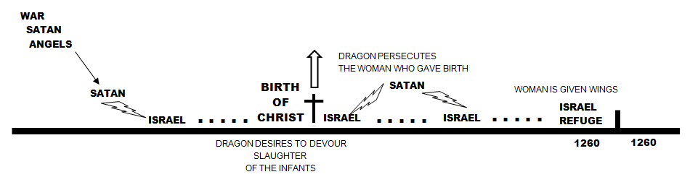

Closing Scenes

As the flight of the woman is reserved for end times – first half of Daniel’s tribulation – so is the reaction of the dragon. He is not done. He spews out a flood of water to overtake her. But the earth opens up and swallows the flood.

So we need not look to some historic event against Israel that this flood might picture, but instead anticipate an attack on Israel that is defeated in some way by earthly effects.

The nourishing of Israel for 1260 days – or one entire half of the seven-year period – seems difficult to reconcile with the rebirth of Israel and their mission to evangelize, only to be scurried away with no effect in the world for that period.

Thus, many authors relate the woman representing Israel here to be the 144,000, whom we will see as having been preserved from the affairs of men in their descriptions in chapter 14.

Which makes for a complex shifting of her representation in these scenes: she is Israel as the family of Jacob, then as the nation in the person of the mother of Christ giving birth, then the nation persecuted, then the 144,000 select reborn Jews of the tribulation period.

